**Assignment 6**

Mohsin Rasool  
14L-5045

**Experiment:**We have been provided data set of 300 images of three different objects, elephants, dinosaurs and buses, of dimensions 50x50.   
We developed three Self Organizing Maps of grid 10x10, 20x20 and 30x30 and used different values of decay rates λ and β and observe the behavior of data. we also vary the neighborhood radius size σ2 to examine its effect on the map. To test out our results we used KNN Classifier, with k value set to 3, to classify our SOM points and calculated accuracy rate for each variation which is laid out in Table 1. For all our SOMs we ran the algorithm for 2 epochs and $η_{o}$ equal to 1.

**Observation:**With 10x10 SOM, we observed that decay rates of 0.6 with ${}_{o}^{2}$ equal to 1 gave best results of 93.3% but it has error 18% error rate for elephants. See Figure (1).

With 20x20 SOM, we observed that decay rates of 0.1 with ${}_{o}^{2}$ equal to 1 gave best results of 93.3% accuracy but it has error 14% error rate for elephants. With respect to 10x10 SOM, we achieved same accuracy at higher decay rate (0.6). See Figure (2).

With 30x30 SOM, we observed that decay rates of 0.3 with ${}_{o}^{2}$ equal to 5 gave best results of 95.3%. So far, it's the best combination we tried. See Figure (3).

|  |  |  |  |  |  |  |  |
| --- | --- | --- | --- | --- | --- | --- | --- |
| **Map Size** | **σ2** | **λ and β** | **Bus Errors** | **Dinosaurs Errors** | **Elephant Errors** | **Error rate (%)** | **Accuracy Rate (%)** |
| 10x10 | 1 |      | 1 | 0 | 40 | 13.67% | 86.33% |
|      | 4 | 0 | 28 | 10.67% | 89.33% |
|      | 4 | 0 | 24 | 9.33% | 90.67% |
|      | 2 | 0 | 18 | 6.67% | 93.33% |
| 5 |      | 3 | 1 | 34 | 12.67% | 87.33% |
|      | 5 | 1 | 25 | 10.33% | 89.67% |
| 20x20 | 1 |      | 5 | 0 | 17 | 7.33% | 92.67% |
|      | 4 | 2 | 14 | 6.67% | 93.33% |
|      | 3 | 3 | 24 | 10.00% | 90.00% |
|      | 10 | 4 | 29 | 14.33% | 85.67% |
| 5 |      | 3 | 0 | 23 | 8.67% | 91.33% |
|      | 7 | 0 | 14 | 7.00% | 93.00% |
| 30x30 | 1 |      | 12 | 7 | 27 | 15.33% | 84.67% |
|      | 17 | 5 | 22 | 14.67% | 85.33% |
|      | 27 | 15 | 38 | 26.67% | 73.33% |
|      | 28 | 36 | 46 | 36.67% | 63.33% |
| 5 |      | 3 | 0 | 15 | 6.00% | 94.00% |
|      | 4 | 0 | 10 | 4.67% | 95.33% |

Table 1: Summary of the Experiment   
(k=3 for KNN Classifier algorithm)

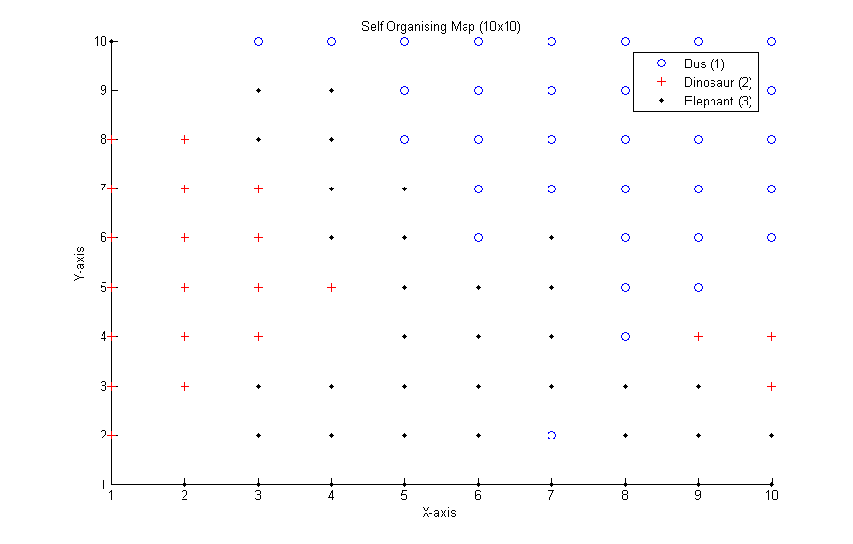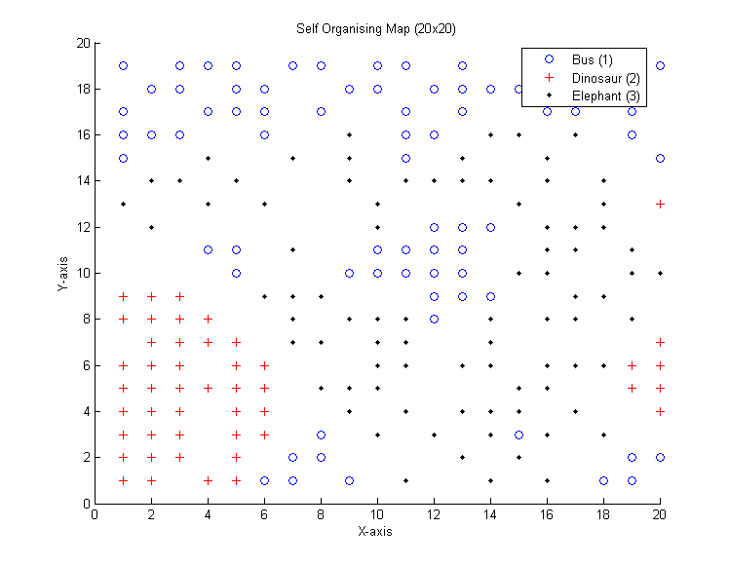

|  |  |
| --- | --- |
| Figure : SOM(10x10) | Figure 2: SOM (20x20) |
| (with epochs = 2, $η_{o}=1$, ${}_{o}^{2}=1$, λ=β=0.6) | (with epochs = 2, $η_{o}=1$, ${}_{o}^{2}=1,$ λ=β=0.1) |

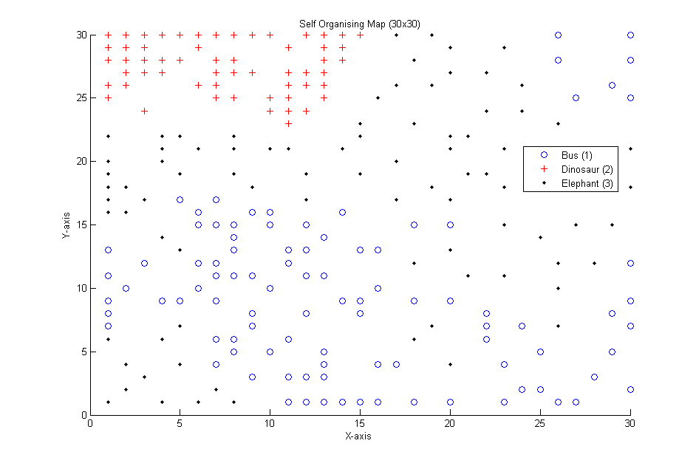

|  |
| --- |
| Figure 2: SOM(30x30) |
| (with epochs = 2, $η_{o}=1$, ${}_{o}^{2}=5,$ λ=β=0.3) |